ST. XAVIER’S COLLEGE

**(Affiliated to Tribhuvan University)**

Maitighar, Kathmandu



**Computer Graphics Lab Assignment #8**

**Reflection on X and Y axis**

**Submitted by:**

Divya Jyoti Pokharel

013BSCCSIT019

**Submitted to:**

|  |  |
| --- | --- |
| Er. Anil Sah  Lecturer, St. Xavier’s College |  |

Source Code

//---------------------------------------------------------------------------

#include <vcl\vcl.h>

#pragma hdrstop

#include "Unit1.h"

//---------------------------------------------------------------------------

#pragma resource "*.dfm"

TForm1 *Form1;

//---------------------------------------------------------------------------

__fastcall TForm1::TForm1(TComponent* Owner)

: TForm(Owner)

{

}

//---------------------------------------------------------------------------

void __fastcall TForm1::refxClick(TObject *Sender)

{

int y=input->Height;

int x=input->Width;

int xmin=x/2;

int ymin=y/2;

int i,j;

int a,b;

for(i=0;i<=x;i++){

for(j=0;j<=y;j++){

a= i;

b=-(j-ymin)+ymin;

output->Canvas->Pixels[a][b]=input->Canvas->Pixels[i][j];

}

}

//Drawing X axis

output->Canvas->MoveTo((output->Width)/2,0);

output->Canvas->LineTo((output->Width)/2,output->Height);

//Drawing X axis

output->Canvas->MoveTo(0,output->Height/2);

output->Canvas->LineTo(output->Width,output->Height/2);

}

//---------------------------------------------------------------------------

void __fastcall TForm1::refyClick(TObject *Sender)

{

int y=input->Height;

int x=input->Width;

int xmin=x/2;

int ymin=y/2;

int i,j;

int a,b;

for(i=0;i<=x;i++){

for(j=0;j<=y;j++){

a= -(i-xmin)+xmin;

b= j;

output->Canvas->Pixels[a][b]=input->Canvas->Pixels[i][j];

}

}

//Drawing X axis

output->Canvas->MoveTo((output->Width)/2,0);

output->Canvas->LineTo((output->Width)/2,output->Height);

//Drawing X axis

output->Canvas->MoveTo(0,output->Height/2);

output->Canvas->LineTo(output->Width,output->Height/2);

}

//---------------------------------------------------------------------------

Output

Reflection on X axis

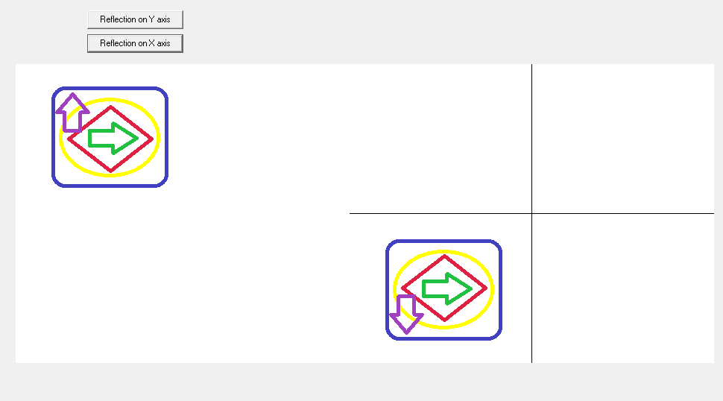

Reflection on Y axis

